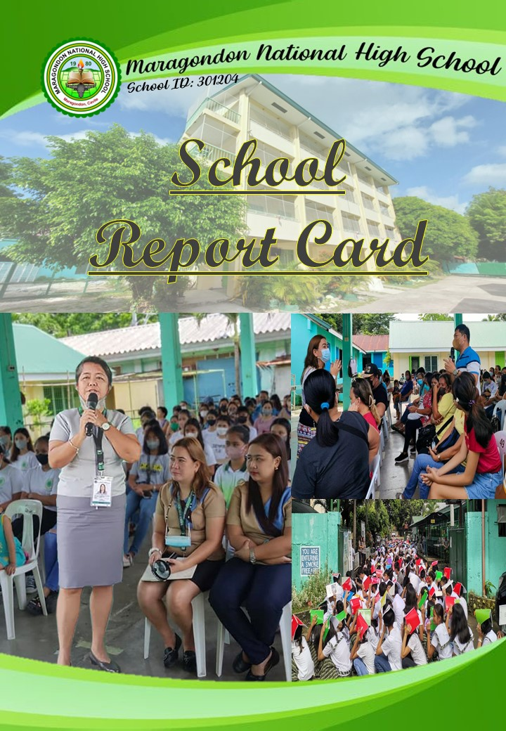

**School Profile**

1. Enrollment

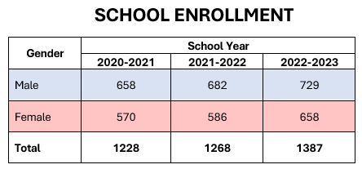

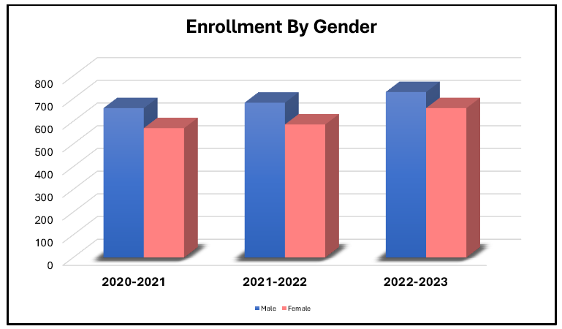





The gradual growth in enrollment rate was driven by a constant increase in the number of Grade 7 enrollees as well as a bigger number of transferred-in learners brought about by the relocation activities in the nearby municipalities.

**School Profile**

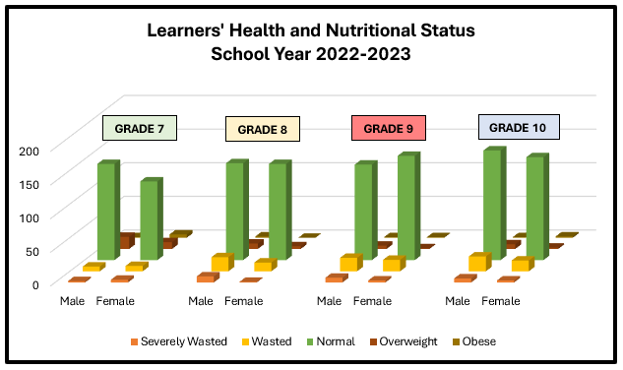2. Health and Nutritional Status

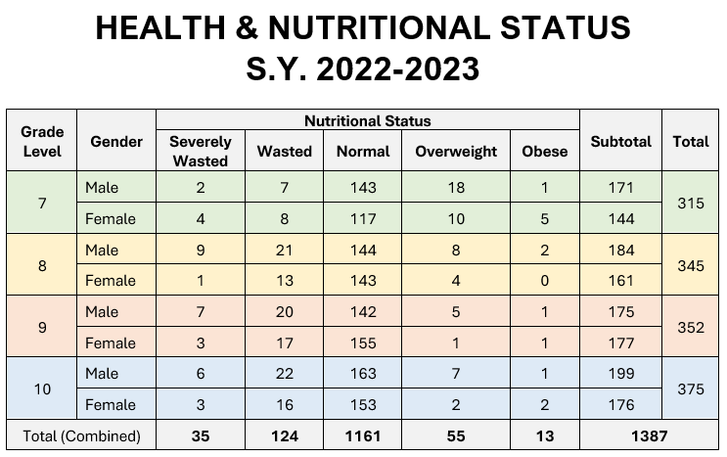

83.71% of learners have a normal nutritional status; 8.92% are wasted; 3.93% are overweight, 2.51% are severely waste and only 0.93% are obese. Interventions such as nutrition education and feeding programs will be implemented.

**School Profile**

3. Learners Materials

TEXT BOOKS

|  |  |  |  |  |
| --- | --- | --- | --- | --- |
| Year Level | Subject | Quantity | Excess | Shortage |
| G7 | ENGLISH | 300 | 0 | 2 |
| MATHEMATICS | 300 | 0 | 2 |
| SCIENCE & HEALTH | 468 | 166 | 0 |
| FILIPINO | 350 | 48 | 0 |
| ARALING PANLIPUNAN | 343 | 41 | 0 |
| MUSIC | 429 | 127 | 0 |
| ARTS | 343 | 41 | 0 |
| PHYSICAL EDUCATION | 453 | 151 | 0 |
| HEALTH | 453 | 151 | 0 |
| TLE | 200 | 0 | 102 |
| ESP | 350 | 48 | 0 |



|  |  |  |  |  |
| --- | --- | --- | --- | --- |
| Year Level | Subject | Quantity | Excess | Shortage |
| G8 | ENGLISH | 0 | 0 | 301 |
| MATHEMATICS | 350 | 49 | 0 |
| SCIENCE & HEALTH | 410 | 49 | 0 |
| FILIPINO | 350 | 49 | 0 |
| ARALING PANLIPUNAN | 317 | 16 | 0 |
| MUSIC | 350 | 49 | 0 |
| ARTS | 350 | 48 | 0 |
| PHYSICAL EDUCATION | 350 | 49 | 0 |
| HEALTH | 350 | 49 | 0 |
| TLE | 200 | 0 | 101 |
| ESP | 348 | 47 | 0 |





TEXT BOOKS

|  |  |  |  |  |
| --- | --- | --- | --- | --- |
| Year Level | Subject | Quantity | Excess | Shortage |
| G9 | ENGLISH | 396 | 48 | 0 |
| MATHEMATICS | 349 | 1 | 0 |
| SCIENCE & HEALTH | 348 | 0 | 0 |
| FILIPINO | 349 | 1 | 0 |
| ARALING PANLIPUNAN | 386 | 38 | 0 |
| MUSIC | 349 | 1 | 0 |
| ARTS | 349 | 1 | 0 |
| PHYSICAL EDUCATION | 349 | 1 | 0 |
| HEALTH | 553 | 205 | 0 |
| TLE | 54 | 0 | 294 |
| ESP | 348 | 0 | 0 |

|  |  |  |  |  |
| --- | --- | --- | --- | --- |
| Year Level | Subject | Quantity | Excess | Shortage |
| G10 | ENGLISH | 354 | 13 | 0 |
| MATHEMATICS | 430 | 89 | 0 |
| SCIENCE & HEALTH | 365 | 24 | 0 |
| FILIPINO | 360 | 19 | 0 |
| ARALING PANLIPUNAN | 350 | 9 | 0 |
| MUSIC | 379 | 38 | 0 |
| ARTS | 379 | 38 | 0 |
| PHYSICAL EDUCATION | 380 | 39 | 0 |
| HEALTH | 380 | 39 | 0 |
| TLE | 40 | 0 | 301 |
| ESP | 363 | 22 | 0 |



**School Profile**

3. Learners Materials

MODULES

|  |  |  |  |  |
| --- | --- | --- | --- | --- |
| *SECOND QUARTER* | | | | |
| LEARNING  AREA | **GRADE LEVEL** | | | |
| **7** | **8** | **9** | **10** |
| ESP | 314 | 345 | 414 | 283 |
| AP | 312 | 345 | 414 | 283 |
| English | 314 | 345 | 414 | 283 |
| Filipino | 314 | 345 | 414 | 283 |
| Math | 314 | 345 |  | 283 |
| Science | 314 | 345 | 414 | 283 |
| MAPEH |  |  |  |  |
| Music | 314 | 345 | 414 | 283 |
| Arts | 314 | 345 | 414 | 283 |
| PE | 314 | 345 | 414 | 283 |
| Health | 314 | 345 | 414 | 283 |
| TLE |  |  |  |  |

|  |  |  |  |  |  |  |
| --- | --- | --- | --- | --- | --- | --- |
|  | *THIRD QUARTER* | | | | | |
| LEARNING  AREA | |  | **GRADE LEVEL** | | | |
| **7** | **8** | **9** | **10** |
| ESP | |  | 345 | 253 | 281 | 298 |
|  | | Module 1-2 |  | 217 |  |  |
| AP | |  | 514 | 509 | 281 | 298 |
|  | | Module 1 | 104 | 115 | 114 | 132 |
|  | | Module 2 |  |  |
|  | | Module 3 |  |  |
|  | | Module 4 |  |  |
|  | | Module 5 |  |  |  |
| English | |  | 241 | 253 | 281 | 298 |
|  | | Module 1 | 98 |  | 228 | 96 |
|  | | Module 2 |  | 96 |
|  | | Module 3 |  | 96 |
|  | | Module 4 |  | 96 |
| Filipino | |  | 514 | 256 |  | 298 |
| Math | |  |  | 509 | 281 | 106 |
|  | | Module 1&2 | 241 |  |  | 600 |
| Science | |  | 241 | 253 | 281 | 298 |
|  | | Module 1-4 |  |  | 114 |  |
| MAPEH | |  |  |  |  |  |
| Music | |  | 104 | 253 | 118 |  |
| Arts | | Module 1&2 | 102 |  | 117 |  |
| PE | |  | 104 | 253 |  |  |
| Health | | Module 1-4 |  | 114 | 114 | 106 |
| TLE | | Module 1-9 | 152 |  |  |  |
|  | | Module 1-11 |  |  | 169 | 116 |
|  | | CSS | 29 |  |  |  |
|  | | Caregiving | 29 |  |  |  |
|  | | Carpentry | 29 |  |  |  |
|  | | Cookery | 29 |  |  |  |
|  | | Dressmaking | 29 |  |  |  |
|  | | Food Processing | 29 |  |  |  |
|  | | Front Office | 29 |  |  |  |
|  | | Handicraft | 29 |  |  |  |
|  | | Nail Care | 29 |  |  |  |
|  | | Organic Agriculture | 29 |  |  |  |



|  |  |  |  |  |  |  |
| --- | --- | --- | --- | --- | --- | --- |
|  | *FOURTH QUARTER* | | | | | |
| LEARNING  AREA | |  | **GRADE LEVEL** | | | |
|  | **7** | **8** | **9** | **10** |
| ESP | |  | 309 | 345 | 414 | 283 |
| AP | | Module 1-4 |  |  |  | 106 |
| English | | Module 1 | 153 |  | 45 | 40 |
|  | | Module 1-4 |  | 114 |  |  |
| Filipino | |  |  |  |  | 26 |
| Math | |  |  |  | 21 | 52 |
| Science | | Module 1-2 |  | 1 |  | 40 |
| MAPEH | |  |  |  |  |  |
| Music | |  | 17 |  | 17 |  |
| Module 1-3 |  | 114 |  |  |
| Arts | |  | 17 |  |  |  |
| PE | |  |  |  | 31 |  |
| Health | | Module 1&2 |  |  |  | 96 |
| TLE | |  |  |  |  |  |



**School Profile**

3. Learners Materials 



|  |  |
| --- | --- |
| DESCRIPTION | QUANTITY |
| Monoblock Chairs | 24 |
| Study Table | 6 |
| Metal Shelves Big | 2 |
| Stand Fan | 1 |
| Epson L110 Printer | 1 |
| Metal Shelves Small | 4 |
| LCD TV | 1 |
| Wooden Shelves | 2 |
| Personal Computer | 2 |
| Wooden Cabinet | 1 |
| Filing Cabinet | 1 |
| Teachers Table | 1 |
| Teachers Chair | 1 |
| Magazine Rack | 1 |
| Globe | 6 |





**School Profile**

3. Learners Materials 



**COMPUTER LABORATORY**

|  |  |  |  |
| --- | --- | --- | --- |
| DESCRIPTION | QUANTITY | | |
|  | **SY 2020-2021** | **SY 2021-2022** | **SY 2022-2023** |
| Epson Projector | 1 | 1 | 1 |
| Desktop Computer | 20 | 19 | 17 |
| PA Speaker | 1 | 1 | 1 |
| LED TV | 1 | 2 | 2 |
| Printer | 1 | 1 | 2 |
| Cross Headed Screw | 5 | 5 | 12 |
| Flat Headed Screw | 5 | 5 | 15 |
| Pliers | 0 | 0 | 2 |
| Long Nose Pliers | 0 | 0 | 1 |
| D-Link Switch Hub | 4 | 4 | 4 |
| TP-Link WIFI router | 1 | 1 | 1 |
| Anti-Static Wrist Trap | 1 | 1 | 11 |
| LAN Cable Tester | 4 | 3 | 5 |
| Laptop (Samsung) | 1 | 1 | 1 |
| Crimping Tools | 4 | 1 | 1 |



**School Profile**

3. Learners Materials



|  |  |
| --- | --- |
| Description | On Hand Per Count |
| (Quantity) |
| A) BEAKERS |  |
| 600 mL | 1 |
| 500 mL | 10 |
| 400 mL | 2 |
| 300 mL | 9 |
| 250 mL | 20 |
| 200 mL | 1 |
| B) GRADUATED CYLINDER |  |
| 500 mL | 1 |
| 100 mL | 5 |
| 25 mL | 1 |
| 10 mL | 7 |
| C) ERLEN MEYER FLASK |  |
| 500 mL | 1 |
| 300 mL | 9 |
| 250 mL | 43 |
| D) THERMOMETER | 20 |
| E) FLORENCE FLASK | 5 |
| F) WATCH GLASS | 15 |
| G) PETRI DISH | 32 |
| H) FUNNEL | 9 |
| I) TEST TUBE | 142 |
| J) EVAPORATING DISH | 6 |
| K) STIRRING ROD | 11 |
| L) ALCOHOL LAMP | 13 |
| M) THISTLE TUBE | 3 |
| N) REAGENT BOTTLE | 20 |
| Porcelain |  |
| A) EVAPORATING DISH | 30 |
| B) MORTAR & PESTLE | 17 |
| Plastic Wares |  |
| A) BEAKERS | 14 |
| B) STIRRING ROD | 2 |
| C) FUNNEL | 11 |
| D) GRADUATED CYLINDER | 14 |
| E) SYRINGE | 3 |
| Plastic Wares |  |
| A) TRIPOD | 12 |
| B) SPRING BALANCE | 18 |
| C) SINGLE PAN BALANCE | 6 |
| D) DOUBLE PAN BALANCE | 16 |
| E) IRON RING WITH CLAMP | 7 |
| F) IRON STAND | 18 |
| G) IRON RING | 11 |
| H) IRON CLAMP | 13 |
| I) TEST TUBE RACK | 2 |
| J) TEST TUBE RACK (wood) | 5 |
| others |  |
| A) DISSECTING SET | 1 |
| B) SET OF WEIGHTS (BIG) | 2 |
| C) SET OF WEIGHTS (SMALL) | 5 |
| D) CONVERTER | 3 |
| E) TIMER | 2 |
| F) OPTICAL BENCH | 2 |
| G) WEIGHING SCALE (plastic) | 2 |
| H) MINI SCALE | 1 |
| I) INCLINED PLANE (wooden air resistance) | 20 |
| J) MINI FORCEP | 6 |
| K) HORSE-U MAGNET | 3 |
| L) HALOGEN LAMP | 3 |
| M) MICRO HAE MATOCRIT (tube) | 5 |
| N) MICROSCOPE (functional) | 3 |
| for PHYSICS |  |
| 1. WIND VELOCITY INDICATOR | 1 |
| 2. CONSTEL PHYSICS FOR EVERYDAY LIFE | 1 |
| 3. LEARNING PHYSICS IN ONE NATION (DVD) | 35 |
| 4. ACE EDUCATIONAL MEDIA (DVD) | 19 |
| 5. BURETTE / TITRATION OF ACIDS | 1 |
| 6. ATOMIC MODEL (BALLS) | 2 |
| 7. MANOMETER APPARATUS | 1 |
| 8. JAYRO BOARD | 4 |
| 9. 60 TDE LEAF APPARATUS | 1 |
| 10. IRON FILINGS | 1 |
| 11. DIRECT VOLT METER | 3 |
| 12. PRIME MOVER | 2 |
| 13. VERNOULLI'S PRINCIPLE | 2 |
| 14. SOLAR CAR | 1 |
| 15. PENDULUM | 1 |
| 16. CONDENSER | 1 |
| 17. GLASS TUBING | 1 |
| 18. ADAPTER | 1 |
| 19. RAIN GAUGE | 1 |
| 20. MIRROR SET - ANEVOID / WIND MILL | 1 |
| 21. MINI - THISTLE TUBE (PRESSURE) | 6 |
| 22. MULTI-TESTER | 2 |
| 23. DIGITAL MULTI-TESTER | 2 |
| 24. PHYSICS ELECTRONICS SUPPLIES SET | 5 |
| 25. CORK BORRER W/ SET OF CORK STOPPER | 4 |
| 26. MAGNIFYING GLASS (small) | 2 |
| 27. MAGNIFYING GLASS | 4 |
| 28. SLIDES | 5 |
| 29. HALOGEN LAMP | 2 |
| 30. BLACK SET OF WEIGHTS | 1 |
| stockroom |  |
| 1. FRAME HUMAN EMBRYO | 3 |
| 2. REPRODUCTIVE SYSTEM | 2 |
| 3. MODEL HUMAN HEART | 3 |
| 4. HUMAN EAR | 2 |
| 5. EYE MODEL | 1 |
| 6. HUMAN ANATOMY MODELS | 5 |
| 7. EARTH MODEL | 3 |
| 8. SET WEIGHT SLOTTED BRASS | 2 |
| 9. FRAME COLLECTION OF MINERAL | 2 |







**School Profile**

4. Teachers’ Professional Development

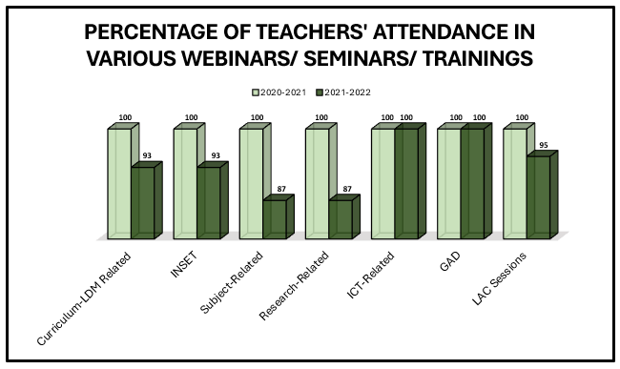



Over the last two school years, teachers have actively participated in a variety of trainings, webinars, and seminars, either online or in limited face-to-face settings. Because distance learning is required, more teachers attended Curriculum and LDM-Related Trainings as well as ICT-based/anchored workshops to equip themselves with the necessary skills.

**School Profile**

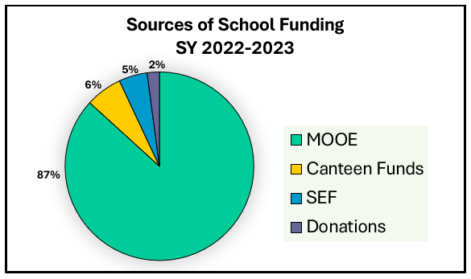5. Funding Sources



Maintenance and Other Operating Expenses (MOOE) account up a sizable portion of the school’s funds. In addition to this are the Special Education Fund (SEF), donations from stakeholders and income from canteen operations.

****00

**School Profile**

****6. School Awards and Recognitions









**School Profile**

****6. School Awards and Recognitions







**Performance Indicators: Access**

7. Number and rate of dropouts by cause

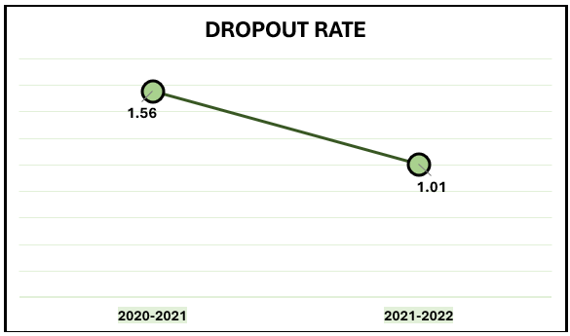

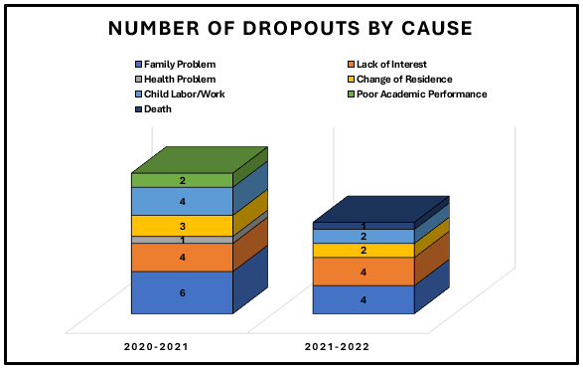

Teachers' consistent efforts in conducting parent-teacher dialogues and home visitations contributed significantly to lowering the dropout rate from 1.56 in SY 2020-2021 to 1.01 in SY 2021-2022. Dropping out is still primarily due to family issues followed by a lack of interest.

**Performance Indicators: Quality**

8. Percentage of learners who completed the School Year (Promotion Rate)

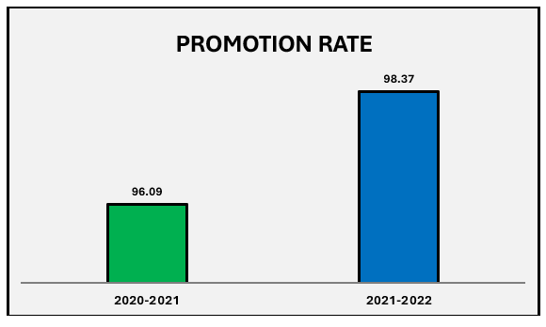

**Performance Indicators: Quality**

For School Year 2021-2022, the promotion rate increased by 2.28%. It is assumed that students have already adjusted to the new normal setting compared to the first year of distance learning.

9. Learning Outcome Assessment (LOA) – by Mean Percentage Score (MPS)

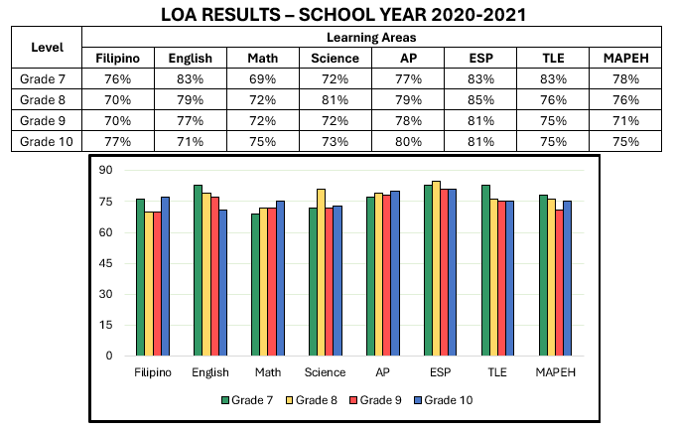

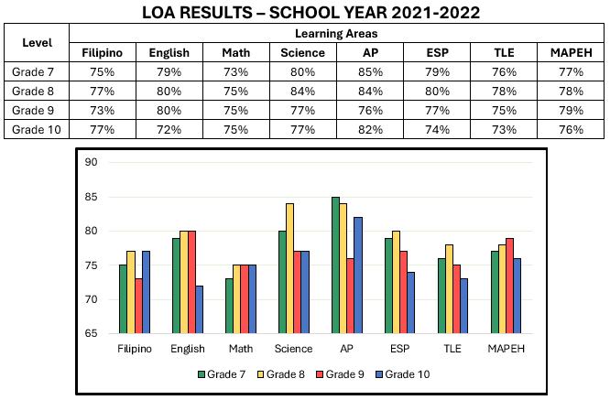



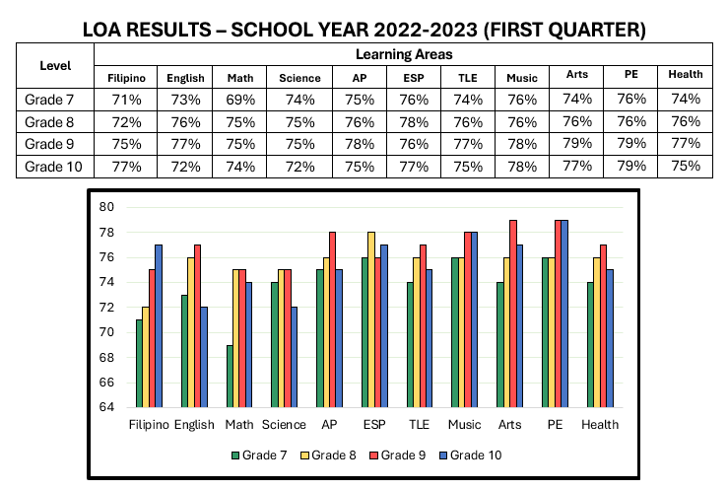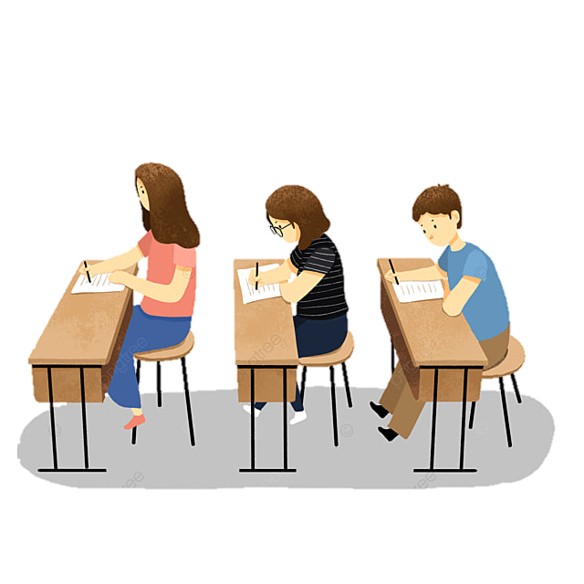

In the last two school years, Mathematics got the lowest Level of Assessment results. At present, the department is intensifying its intervention activities through Project ABC (Accuracy in Basic Computation).

**Performance Indicators: Quality**

10. Literacy Level





|  |  |  |  |  |  |  |  |  |  |
| --- | --- | --- | --- | --- | --- | --- | --- | --- | --- |
| **Level** | **Frustration Level** | | | **Instructional Level** | | | **Independent Level** | | |
| **Total** | **Male** | **Female** | **Total** | **Male** | **Female** | **Total** | **Male** | **Female** |
| **Pre-Test Results** | | | | | | | | |
| Grade 7 | 132 | 84 | 48 | 105 | 61 | 44 | 94 | 41 | 53 |
| Grade 8 | 29 | 24 | 5 | 164 | 85 | 79 | 145 | 59 | 86 |
| Grade 9 | 57 | 44 | 13 | 242 | 116 | 126 | 51 | 15 | 36 |
| Grade 10 | 64 | 22 | 42 | 211 | 105 | 106 | 112 | 55 | 57 |







|  |  |  |  |  |  |  |  |  |  |
| --- | --- | --- | --- | --- | --- | --- | --- | --- | --- |
| **Level** | **Frustration Level** | | | **Instructional Level** | | | **Independent Level** | | |
| **Total** | **Male** | **Female** | **Total** | **Male** | **Female** | **Total** | **Male** | **Female** |
| **Pre-Test Results** | | | | | | | | |
| Grade 7 | 184 | 111 | 73 | 90 | 46 | 44 | 129 | 68 | 61 |
| Grade 8 | 46 | 35 | 11 | 165 | 78 | 87 | 120 | 53 | 67 |
| Grade 9 | 22 | 16 | 6 | 195 | 103 | 92 | 77 | 0 | 77 |
| Grade 10 | 7 | 5 | 2 | 44 | 27 | 17 | 317 | 161 | 156 |



**Performance Indicators: Governance**

11. School-Based Management Assessment Level

Qualitative Interpretation:

**Developing**

SBM Level

**1**

12. Child-Friendly School Survey Result

CFSS Points

**30**

Qualitative Interpretation:

**Child-Friendly School**

**Performance Indicators: Governance**

****13. Stakeholder’s Attendance to School Activities



**\**





Brigada Eskwela

Tema: Tugon sa Hamon ng

Ligtas na Balik-Aral

**Performance Indicators: Governance**

14. Learner-Teacher Ratio

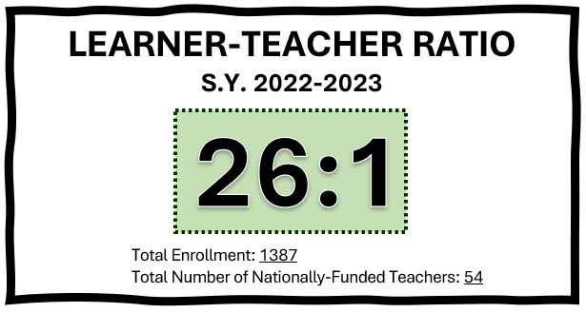

With 1387 students and 54 teachers, the school has an average learner-teacher ratio of 26:1 which indicates that there are 26 students for every one teacher. This only shows that the school has enough number of teachers to handle the learners.

**Performance Indicators: Governance**

15. Learner-Classroom Ratio

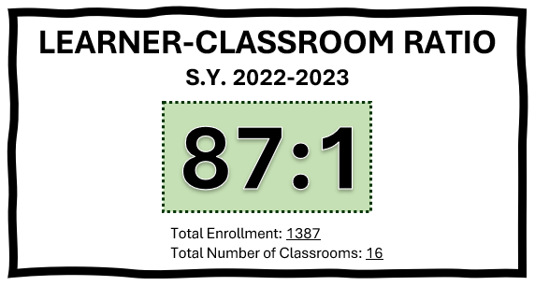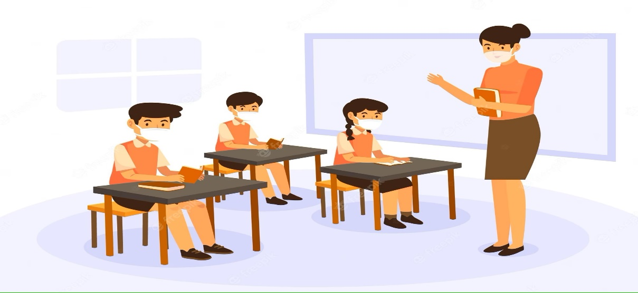­­­­

With 1387 students and 16 classrooms, the school has an average learner-classroom ratio of 87:1. This only shows that the school does not have enough number of classrooms to accommodate the learners. In this regard, the school implemented double shift class schedule.

**Performance Indicators: Governance**

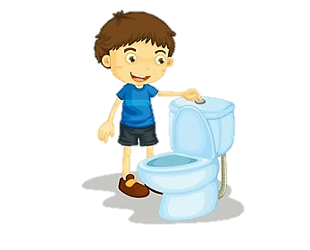16. Learner-Toilet Ratio

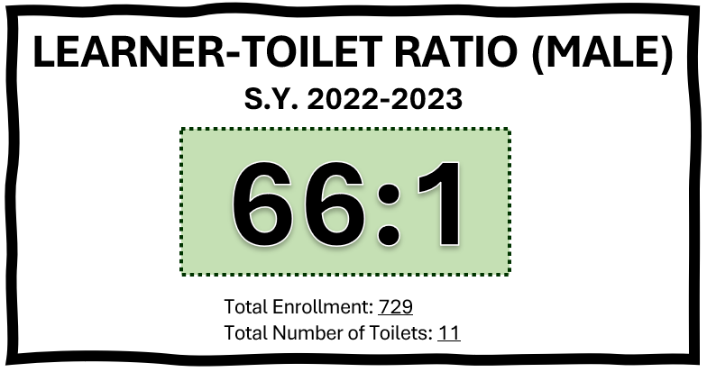

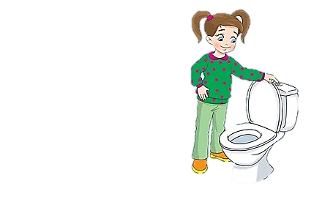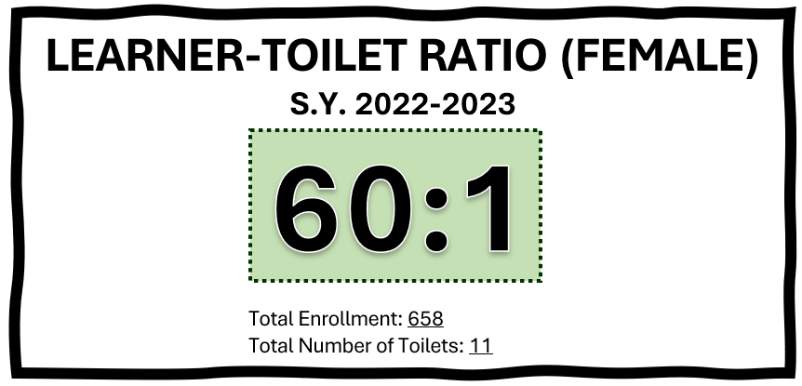

With 1387 students and 22 toilets, the school has an average learner-toilet ratio of 66:1 for male learners and 60:1 for female learners. This only shows that the school does not have sufficient number of comfort rooms.

**Performance Indicators: Governance**

17. Learner-Seat Ratio

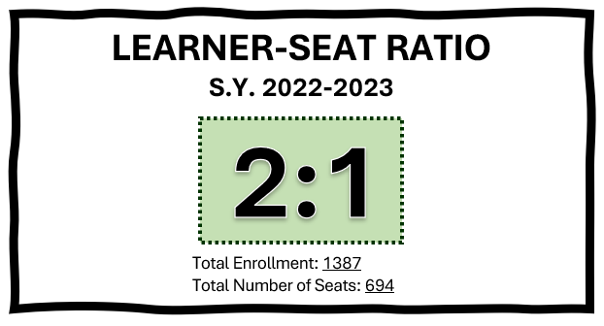

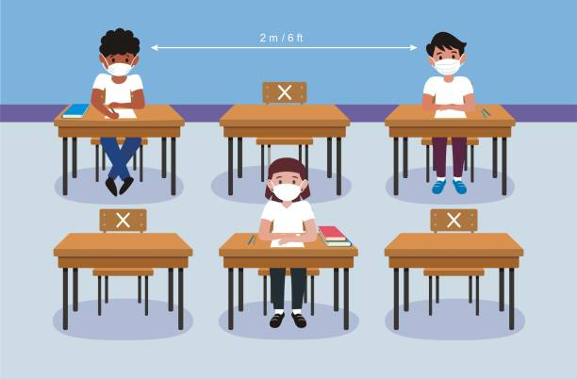

The school has an average learner-seat ratio of 2:1. Since the school implements double shift class schedule, seat shortage is not yet an issue.

**Status of School Projects**

18. Status of Continuous Improvement (CI) projects

1. **CIP in English “Project SPEEDS”**

The Reading teachers of Maragondon National High School conducted the post-assessment and remediations using the Project SPEEDS to enhance and speed up their reading progress. After the initial remediation and intervention conducted by the reading teachers, 20 out of 41 students enrolled in the program achieved independent level in Grade 7, while 21 students in the instructional and frustration level still need further intervention.

The CIP was done successfully with the following recommendations:

1. Continue the implementation of Project SPEEDS in Grade Seven Level.
2. Apply the CI methodology in the preparation of other school’s project/program proposals.
3. Strictly implement “No Read, No Move Policy” in Grade Seven Level.
4. Share CI methodology in the different schools within the district.

**Project Closure**

* Continuous Implementation of **Project SPEED** to all grade levels
* Strict Implementation of *No Read, No Move Policy* in Grade Seven Level
* Monitoring and evaluation on the project’s progress.
* To keep track the reading level of students
* To address the needs and concerns of students before moving on to higher grade level
* To keep track on the current status of the project and look for areas of improvement

**OBJECTIVES**

**ACTIVITIES**



**Status of School Projects**

19. Other stakeholders’ accomplishments

* GPTA 2022 Projects

Zumba is one of the most well-known fitness fads that has managed to captivate millions of people worldwide and motivate them to move for improved health and energy.

Thus, Maragondon National High School through the initiative of School Parent and Teacher Association (SPTA) headed by Mrs. Rowena A. Densing conducted its 2022 ZumBrigada at Maragondon Town Plaza on October 22, 2022.

ZumBrigada is a one-day fundraising dance exercise which generally aimed to generate fund to purchase TV stands with wheels and for classroom innovations. Aside from promoting healthy lifestyle, the activity also aimed strengthening interpersonal relationships among community members and stakeholders.

To join the ZumBrigada, the participants would purchase tickets worth P50.00 in voluntary basis.

****Parents, students, school personnel and other stakeholders supported and participated the Zumba activity. They enjoyed the Zumba event.



**Photo Documentation**

* School Accomplishments
* Linkages

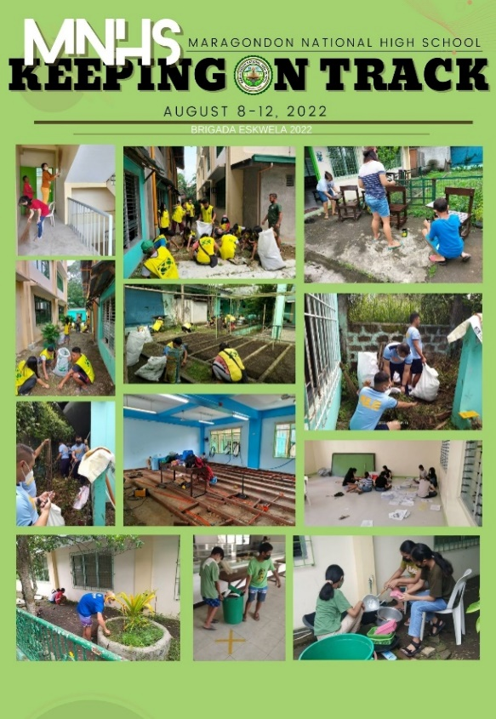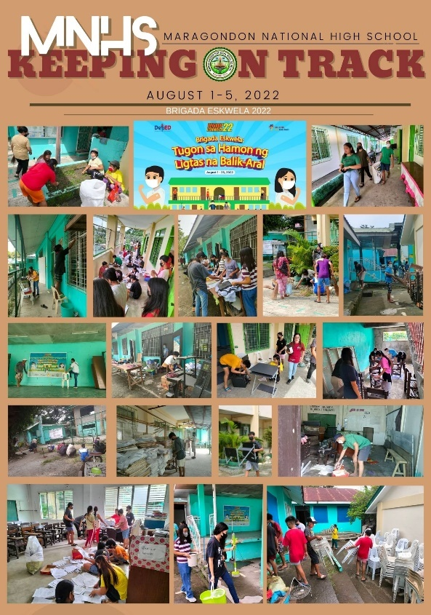

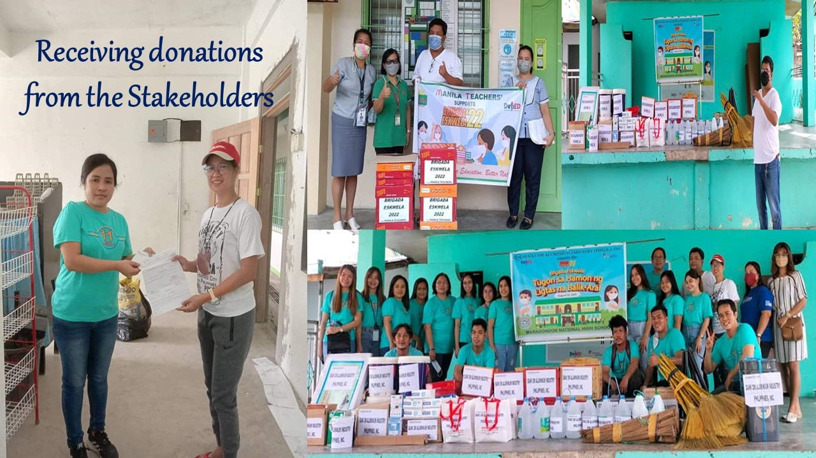



**SPTA School Project: ZumBRIGADA**

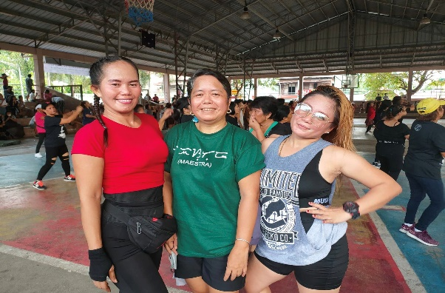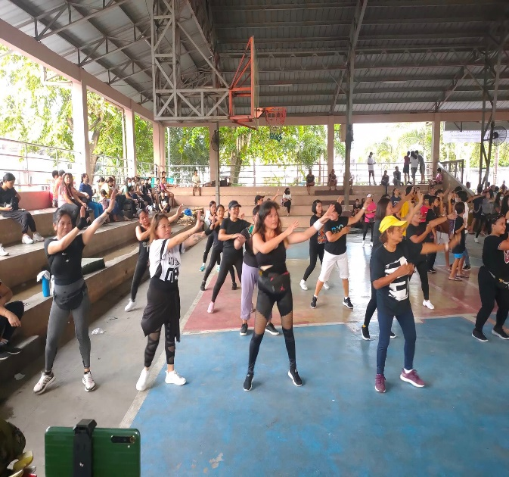

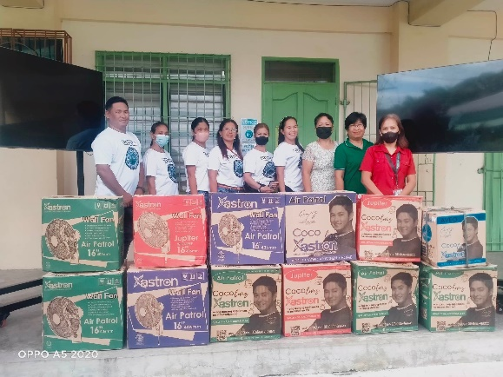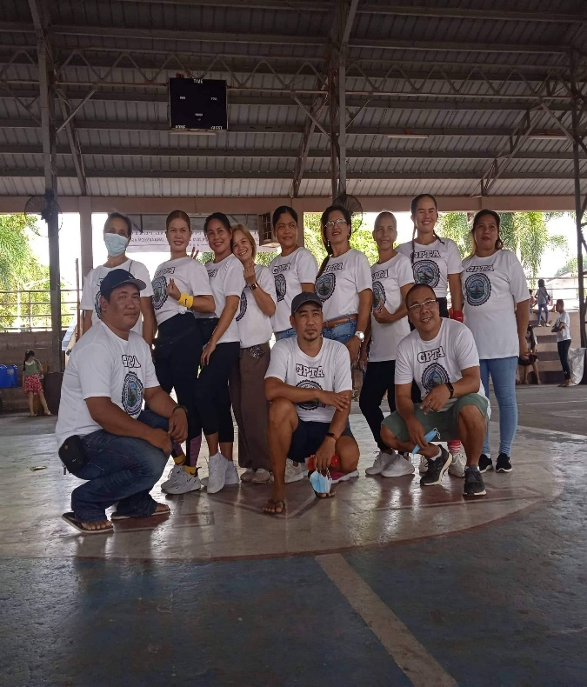

**Stakeholders’ Engagement**

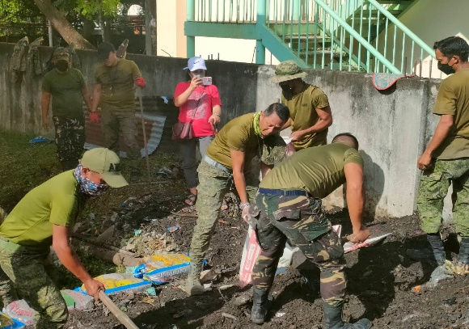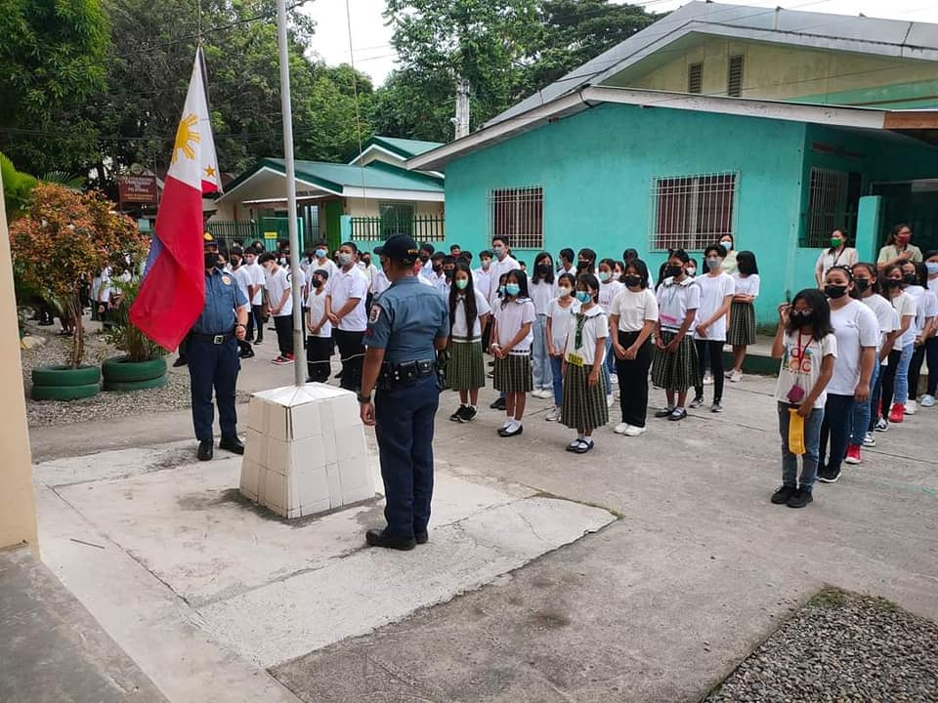

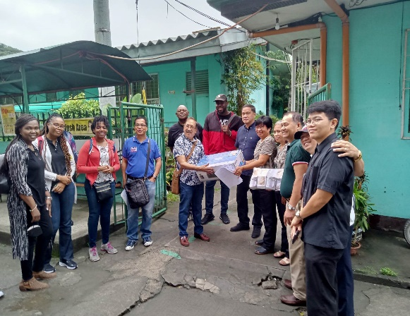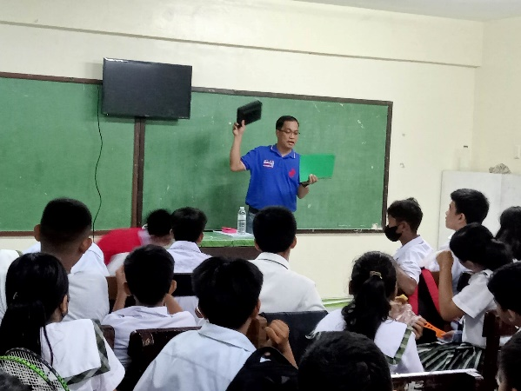



* Capability Building

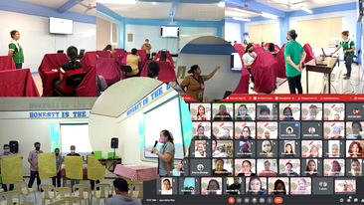

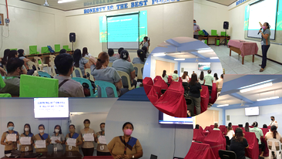



* 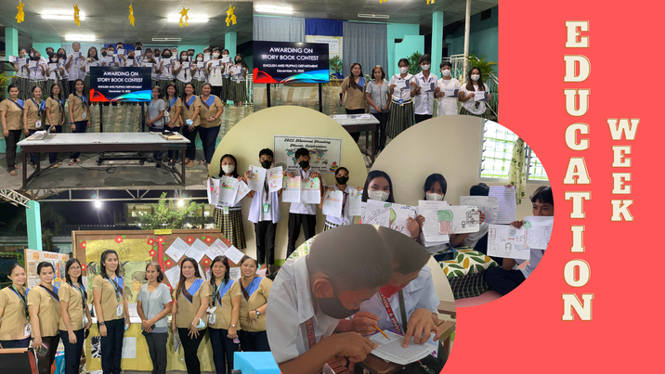School Activities

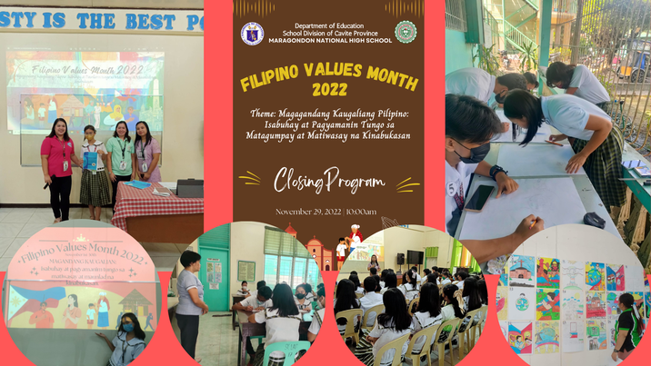

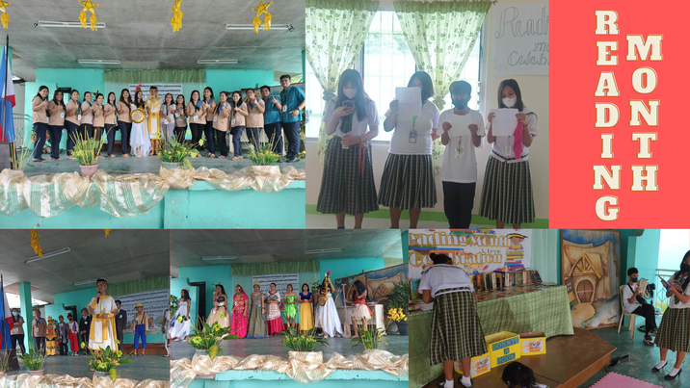



This is to certify that all the data/ information and photos presented in this School Report Card are true and correct in accordance to Deped Order No. 44, s. 2015 entitled Guidelines on the Enhanced School Improvement Planning (SIP) Process and the School Report Card (SRC).

Signed:

**ROSALIA B. ANACAY**

Principal II

**ROWENA A. DENSING**

President

School Parent-Teacher Association

**AMBROCIO C. COMIA**

President

Teacher and Employees Association

**JILLIAN R. GONZALES**

President

Supreme Student Government